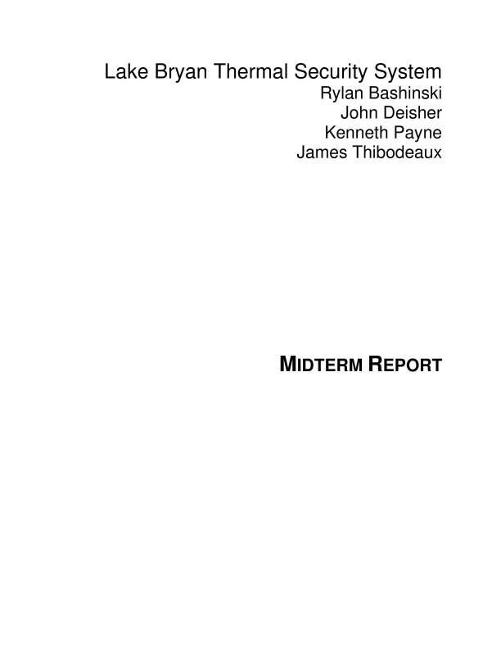
Lake Bryan Thermal Security System Rylan Bashinski
John Deisher
Kenneth Payne
James Thibodeaux
MIDTERM REPORT

Table of Contents
Concept of Operations………………………………………………………………………………1 Functional System Requirements………………………………………………………………...13 Interface Control Document……………………………………………………………………….31 Schedule and Validation…………………………………………………………………………...41
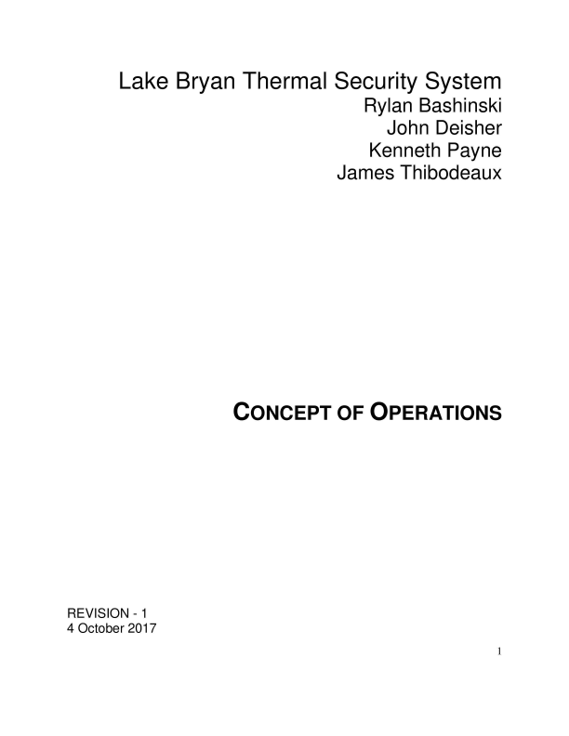
Lake Bryan Thermal Security System Rylan Bashinski
John Deisher
Kenneth Payne
James Thibodeaux
CONCEPT OF OPERATIONS
REVISION - 1
4 October 2017
1

CONCEPT OF OPERATIONS
FOR
Lake Bryan Thermal Security System
APPROVED BY:
_____________________________
Project Leader Date
_____________________________
Prof. S. Kalafatis Date
_____________________________
T/A Date
2
Change Record
Rev .
Date Originator Approvals Description
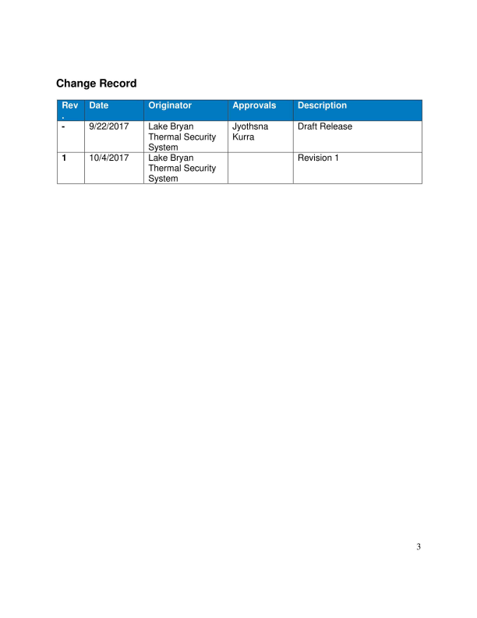
- 9/22/2017 Lake Bryan Thermal Security
System
1 10/4/2017 Lake Bryan Thermal Security
System
Jyothsna Kurra
Draft Release
Revision 1
3
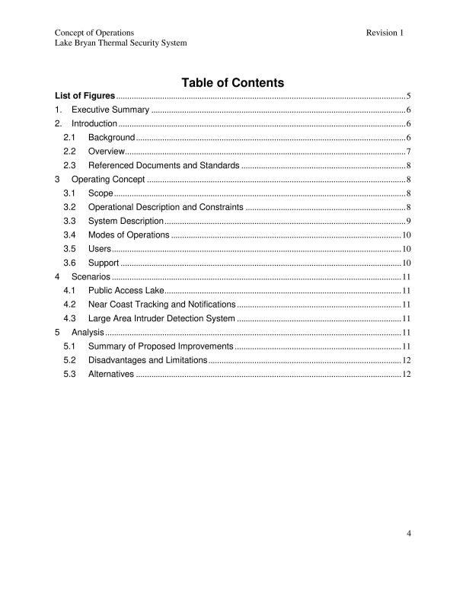
Concept of Operations Revision 1 Lake Bryan Thermal Security System
Table of Contents
List of Figures .................................................................................................................................... 5 1. Executive Summary .................................................................................................................... 6 2. Introduction ................................................................................................................................... 6
2.1 Background ........................................................................................................................... 6 2.2 Overview ................................................................................................................................ 7 2.3 Referenced Documents and Standards ........................................................................... 8
3 Operating Concept ...................................................................................................................... 8 3.1 Scope ..................................................................................................................................... 8 3.2 Operational Description and Constraints ......................................................................... 8 3.3 System Description .............................................................................................................. 9 3.4 Modes of Operations ......................................................................................................... 10 3.5 Users .................................................................................................................................... 10 3.6 Support ................................................................................................................................ 10
4 Scenarios .................................................................................................................................... 11 4.1 Public Access Lake ............................................................................................................ 11 4.2 Near Coast Tracking and Notifications ........................................................................... 11 4.3 Large Area Intruder Detection System ........................................................................... 11
5 Analysis ....................................................................................................................................... 11 5.1 Summary of Proposed Improvements ............................................................................ 11 5.2 Disadvantages and Limitations ........................................................................................ 12 5.3 Alternatives ......................................................................................................................... 12
4

Concept of Operations Revision 1 Lake Bryan Thermal Security System
List of Figures
Figure 1: Lake Bryan Thermal Security System Block Diagram .......................................................... 7 Figure 2: Mesh Network Overview ....................................................................................................... 9
5
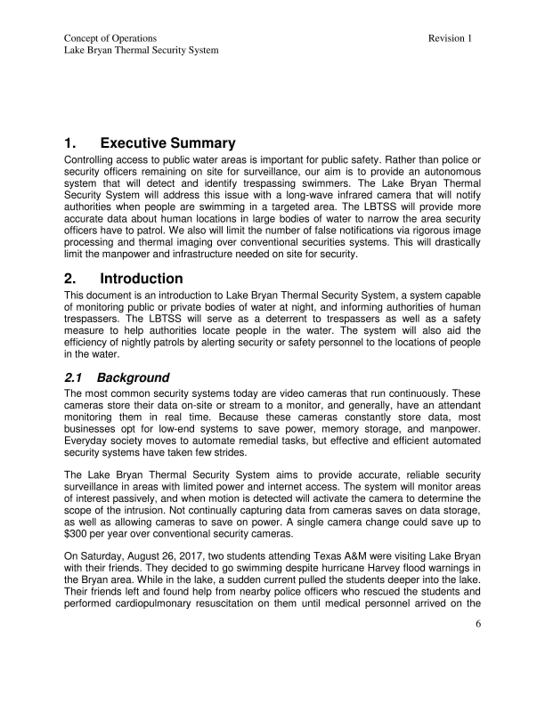
Concept of Operations Revision 1 Lake Bryan Thermal Security System
1. Executive Summary
Controlling access to public water areas is important for public safety. Rather than police or security officers remaining on site for surveillance, our aim is to provide an autonomous system that will detect and identify trespassing swimmers. The Lake Bryan Thermal Security System will address this issue with a long-wave infrared camera that will notify authorities when people are swimming in a targeted area. The LBTSS will provide more accurate data about human locations in large bodies of water to narrow the area security officers have to patrol. We also will limit the number of false notifications via rigorous image processing and thermal imaging over conventional securities systems. This will drastically limit the manpower and infrastructure needed on site for security.
2. Introduction
This document is an introduction to Lake Bryan Thermal Security System, a system capable of monitoring public or private bodies of water at night, and informing authorities of human trespassers. The LBTSS will serve as a deterrent to trespassers as well as a safety measure to help authorities locate people in the water. The system will also aid the efficiency of nightly patrols by alerting security or safety personnel to the locations of people in the water.
2.1 Background
The most common security systems today are video cameras that run continuously. These cameras store their data on-site or stream to a monitor, and generally, have an attendant monitoring them in real time. Because these cameras constantly store data, most businesses opt for low-end systems to save power, memory storage, and manpower. Everyday society moves to automate remedial tasks, but effective and efficient automated security systems have taken few strides.
The Lake Bryan Thermal Security System aims to provide accurate, reliable security surveillance in areas with limited power and internet access. The system will monitor areas of interest passively, and when motion is detected will activate the camera to determine the scope of the intrusion. Not continually capturing data from cameras saves on data storage, as well as allowing cameras to save on power. A single camera change could save up to $300 per year over conventional security cameras.
On Saturday, August 26, 2017, two students attending Texas A&M were visiting Lake Bryan with their friends. They decided to go swimming despite hurricane Harvey flood warnings in the Bryan area. While in the lake, a sudden current pulled the students deeper into the lake. Their friends left and found help from nearby police officers who rescued the students and performed cardiopulmonary resuscitation on them until medical personnel arrived on the
6
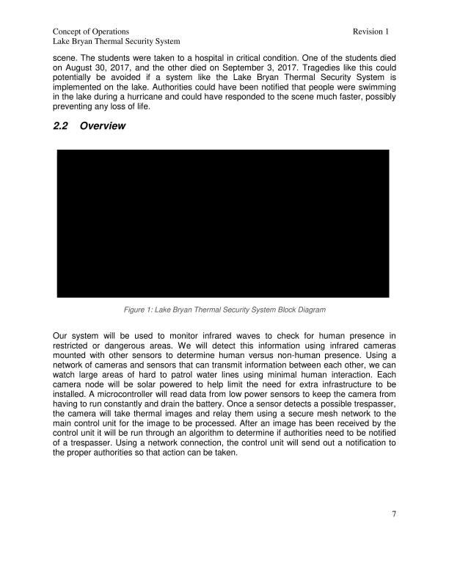
Concept of Operations Revision 1 Lake Bryan Thermal Security System
scene. The students were taken to a hospital in critical condition. One of the students died on August 30, 2017, and the other died on September 3, 2017. Tragedies like this could potentially be avoided if a system like the Lake Bryan Thermal Security System is implemented on the lake. Authorities could have been notified that people were swimming in the lake during a hurricane and could have responded to the scene much faster, possibly preventing any loss of life.
2.2 Overview
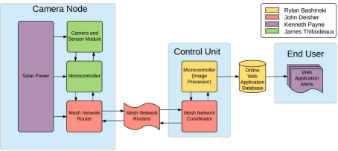Figure 1: Lake Bryan Thermal Security System Block Diagram
Our system will be used to monitor infrared waves to check for human presence in restricted or dangerous areas. We will detect this information using infrared cameras mounted with other sensors to determine human versus non-human presence. Using a network of cameras and sensors that can transmit information between each other, we can watch large areas of hard to patrol water lines using minimal human interaction. Each camera node will be solar powered to help limit the need for extra infrastructure to be installed. A microcontroller will read data from low power sensors to keep the camera from having to run constantly and drain the battery. Once a sensor detects a possible trespasser, the camera will take thermal images and relay them using a secure mesh network to the main control unit for the image to be processed. After an image has been received by the control unit it will be run through an algorithm to determine if authorities need to be notified of a trespasser. Using a network connection, the control unit will send out a notification to the proper authorities so that action can be taken.
7
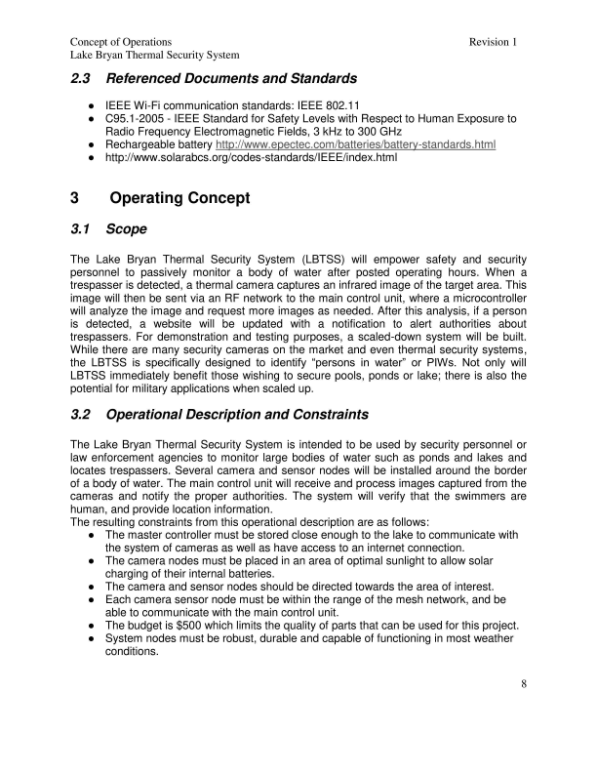
Concept of Operations Revision 1 Lake Bryan Thermal Security System
2.3 Referenced Documents and Standards
IEEE Wi-Fi communication standards: IEEE 802.11
C95.1-2005 - IEEE Standard for Safety Levels with Respect to Human Exposure to Radio Frequency Electromagnetic Fields, 3 kHz to 300 GHz
Rechargeable battery http://www.epectec.com/batteries/battery-standards.html http://www.solarabcs.org/codes-standards/IEEE/index.html
3 Operating Concept
3.1 Scope
The Lake Bryan Thermal Security System (LBTSS) will empower safety and security personnel to passively monitor a body of water after posted operating hours. When a trespasser is detected, a thermal camera captures an infrared image of the target area. This image will then be sent via an RF network to the main control unit, where a microcontroller will analyze the image and request more images as needed. After this analysis, if a person is detected, a website will be updated with a notification to alert authorities about trespassers. For demonstration and testing purposes, a scaled-down system will be built. While there are many security cameras on the market and even thermal security systems, the LBTSS is specifically designed to identify “persons in water” or PIWs. Not only will LBTSS immediately benefit those wishing to secure pools, ponds or lake; there is also the potential for military applications when scaled up.
3.2 Operational Description and Constraints
The Lake Bryan Thermal Security System is intended to be used by security personnel or law enforcement agencies to monitor large bodies of water such as ponds and lakes and locates trespassers. Several camera and sensor nodes will be installed around the border of a body of water. The main control unit will receive and process images captured from the cameras and notify the proper authorities. The system will verify that the swimmers are human, and provide location information.
The resulting constraints from this operational description are as follows: The master controller must be stored close enough to the lake to communicate with the system of cameras as well as have access to an internet connection. The camera nodes must be placed in an area of optimal sunlight to allow solar charging of their internal batteries.
The camera and sensor nodes should be directed towards the area of interest. Each camera sensor node must be within the range of the mesh network, and be able to communicate with the main control unit.
The budget is $500 which limits the quality of parts that can be used for this project. System nodes must be robust, durable and capable of functioning in most weather conditions.
8
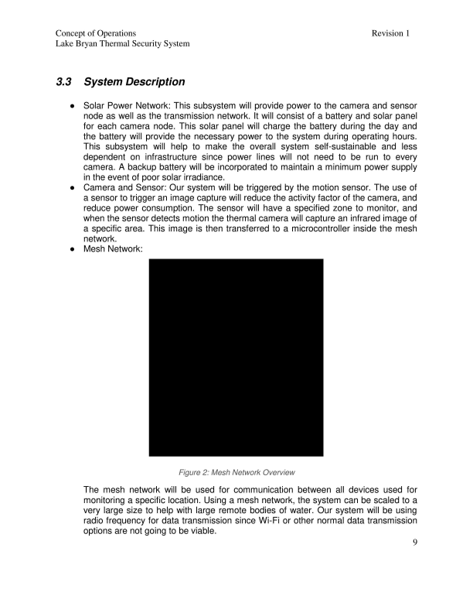
Concept of Operations Revision 1 Lake Bryan Thermal Security System
3.3 System Description
Solar Power Network: This subsystem will provide power to the camera and sensor node as well as the transmission network. It will consist of a battery and solar panel for each camera node. This solar panel will charge the battery during the day and the battery will provide the necessary power to the system during operating hours. This subsystem will help to make the overall system self-sustainable and less dependent on infrastructure since power lines will not need to be run to every camera. A backup battery will be incorporated to maintain a minimum power supply in the event of poor solar irradiance.
Camera and Sensor: Our system will be triggered by the motion sensor. The use of a sensor to trigger an image capture will reduce the activity factor of the camera, and reduce power consumption. The sensor will have a specified zone to monitor, and when the sensor detects motion the thermal camera will capture an infrared image of a specific area. This image is then transferred to a microcontroller inside the mesh network.
Mesh Network:
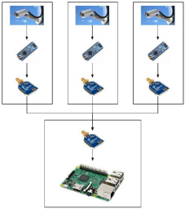
Figure 2: Mesh Network Overview
The mesh network will be used for communication between all devices used for monitoring a specific location. Using a mesh network, the system can be scaled to a very large size to help with large remote bodies of water. Our system will be using radio frequency for data transmission since Wi-Fi or other normal data transmission options are not going to be viable.
9
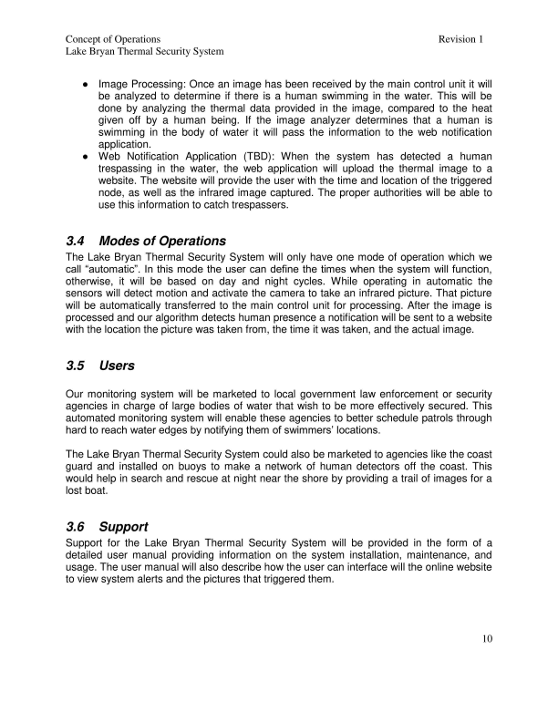
Concept of Operations Revision 1 Lake Bryan Thermal Security System
Image Processing: Once an image has been received by the main control unit it will be analyzed to determine if there is a human swimming in the water. This will be done by analyzing the thermal data provided in the image, compared to the heat given off by a human being. If the image analyzer determines that a human is swimming in the body of water it will pass the information to the web notification application.
Web Notification Application (TBD): When the system has detected a human trespassing in the water, the web application will upload the thermal image to a website. The website will provide the user with the time and location of the triggered node, as well as the infrared image captured. The proper authorities will be able to use this information to catch trespassers.
3.4 Modes of Operations
The Lake Bryan Thermal Security System will only have one mode of operation which we call “automatic”. In this mode the user can define the times when the system will function, otherwise, it will be based on day and night cycles. While operating in automatic the sensors will detect motion and activate the camera to take an infrared picture. That picture will be automatically transferred to the main control unit for processing. After the image is processed and our algorithm detects human presence a notification will be sent to a website with the location the picture was taken from, the time it was taken, and the actual image.
3.5 Users
Our monitoring system will be marketed to local government law enforcement or security agencies in charge of large bodies of water that wish to be more effectively secured. This automated monitoring system will enable these agencies to better schedule patrols through hard to reach water edges by notifying them of swimmers’ locations.
The Lake Bryan Thermal Security System could also be marketed to agencies like the coast guard and installed on buoys to make a network of human detectors off the coast. This would help in search and rescue at night near the shore by providing a trail of images for a lost boat.
3.6 Support
Support for the Lake Bryan Thermal Security System will be provided in the form of a detailed user manual providing information on the system installation, maintenance, and usage. The user manual will also describe how the user can interface will the online website to view system alerts and the pictures that triggered them.
10
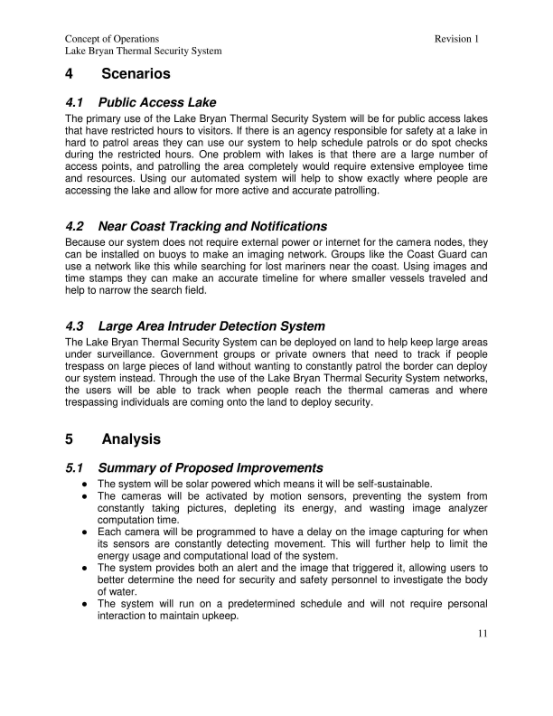
Concept of Operations Revision 1 Lake Bryan Thermal Security System
4 Scenarios
4.1 Public Access Lake
The primary use of the Lake Bryan Thermal Security System will be for public access lakes that have restricted hours to visitors. If there is an agency responsible for safety at a lake in hard to patrol areas they can use our system to help schedule patrols or do spot checks during the restricted hours. One problem with lakes is that there are a large number of access points, and patrolling the area completely would require extensive employee time and resources. Using our automated system will help to show exactly where people are accessing the lake and allow for more active and accurate patrolling.
4.2 Near Coast Tracking and Notifications
Because our system does not require external power or internet for the camera nodes, they can be installed on buoys to make an imaging network. Groups like the Coast Guard can use a network like this while searching for lost mariners near the coast. Using images and time stamps they can make an accurate timeline for where smaller vessels traveled and help to narrow the search field.
4.3 Large Area Intruder Detection System
The Lake Bryan Thermal Security System can be deployed on land to help keep large areas under surveillance. Government groups or private owners that need to track if people trespass on large pieces of land without wanting to constantly patrol the border can deploy our system instead. Through the use of the Lake Bryan Thermal Security System networks, the users will be able to track when people reach the thermal cameras and where trespassing individuals are coming onto the land to deploy security.
5 Analysis
5.1 Summary of Proposed Improvements
The system will be solar powered which means it will be self-sustainable. The cameras will be activated by motion sensors, preventing the system from constantly taking pictures, depleting its energy, and wasting image analyzer computation time.
Each camera will be programmed to have a delay on the image capturing for when its sensors are constantly detecting movement. This will further help to limit the energy usage and computational load of the system.
The system provides both an alert and the image that triggered it, allowing users to better determine the need for security and safety personnel to investigate the body of water.
The system will run on a predetermined schedule and will not require personal interaction to maintain upkeep.
11
Concept of Operations Revision 1 Lake Bryan Thermal Security System
5.2 Disadvantages and Limitations
The Lake Bryan Thermal Security System will have some limitations which include: The system will be optimized to detect adult swimmers and may have difficulty detecting infants or small children.
Due to budget constraints, the camera range will be limited.
The system mainly surveys along the edges of the water and may not detect people far from the camera.
The camera nodes should be placed high to decrease the possibility of vandalism or flood damage.
Camera nodes must be placed in areas with high sunlight to allow the solar panels to generate energy for the system.
5.3 Alternatives
Some alternatives to the Lake Bryan Thermal Security System are:
Conventional Security System monitored by a user.
No security system just signs deterring people from swimming at night. Hiring security personnel to make nightly patrols of the body of water. Power for the system can be provided by running power lines to each individual camera node.
Transmission could be made through a WIFI system or by hardwiring all of the camera nodes together to allow communication.
12
Lake Bryan Thermal Security System Rylan Bashinski
John Deisher
Kenneth Payne
James Thibodeaux
FUNCTIONAL SYSTEM REQUIREMENTS
REVISION – 1
4 October 2017
13
FUNCTIONAL SYSTEM REQUIREMENTS
FOR
Lake Bryan Thermal Security System
APPROVED BY:
_____________________________
Project Leader Date
_____________________________
Prof. S. Kalafatis Date
_____________________________
T/A Date
14
Functional System Requirements Lake Bryan Thermal Security System
Revision - 1
Change Record
Rev .
Date Originator Approvals Description
- 9/26/2017 Lake Bryan Thermal
Security System
1 10/4/2017 Lake Bryan Thermal
Security System
Draft Release
Revision 1
15
Functional System Requirements
Lake Bryan Thermal Security System
Table of Contents
Revision - 1
List of Tables ...................................................................................................................................... 17 List of Figures .................................................................................................................................... 18 1. Introduction ................................................................................................................................. 19
1.1. Purpose and Scope ........................................................................................................... 19 1.2. Responsibility and Change Authority .............................................................................. 20 2. Applicable and Reference Documents .................................................................................. 20 2.1. Applicable Documents ...................................................................................................... 20 2.2. Reference Documents ...................................................................................................... 21 2.3. Order of Precedence ......................................................................................................... 21 3. Requirements ............................................................................................................................. 21 3.1. System Definition ............................................................................................................... 21 3.2. Characteristics .................................................................................................................... 23 3.2.1. Functional / Performance Requirements ................................................................ 23 3.2.2. Physical Characteristics ............................................................................................ 24 3.2.3. Electrical Characteristics ........................................................................................... 25 3.2.4. Environmental Requirements ................................................................................... 27 3.2.5. Failure Propagation .................................................................................................... 27 4. Support Requirements .............................................................................................................. 28 Appendix A Acronyms and Abbreviations ..................................................................................... 29 Appendix B Definition of Terms ...................................................................................................... 30 Appendix C Interface Control Documents ..................................................................................... 30
16
Functional System Requirements
Lake Bryan Thermal Security System
List of Tables
Revision - 1
Table 1: Subsystem Leads ................................................................................................................... 20 Table 2: Applicable Documents ........................................................................................................... 20 Table 3: Reference Documents ............................................................................................................ 21
17
Functional System Requirements
Lake Bryan Thermal Security System
List of Figures
Revision - 1
Figure 1: Project Conceptual Image .................................................................................................... 19 Figure 2: Block Diagram of System .................................................................................................... 22 Figure 3: LBTSS Flowchart ................................................................................................................. 22
18
Functional System Requirements Lake Bryan Thermal Security System
1. Introduction 1.1. Purpose and Scope
Revision - 1
Controlling access to public water areas after normal operating hours is important for public safety. Rather than having police or security personnel constantly on site, our aim is to provide an autonomous system that will detect and identify trespassing swimmers. The Lake Bryan Thermal Security System will notify authorities of PIW by passively monitoring the area with infrared thermography (IRT). With our system data can be gathered regarding where people are swimming in large bodies of water, narrowing the area security personnel need to maintain. We will filter false-positive notifications out with a fully integrated processing software system to analyze the thermal images. Our system will limit the manpower for on-site security, cumbersome infrastructure, and data communication lines.
Figure 1: Project Conceptual Image
19
Functional System Requirements
Lake Bryan Thermal Security System
1.2. Responsibility and Change Authority
Revision - 1
The team leader, John Deisher, will be responsible for verifying all requirements of the project are met. These requirements can only be changed with the approval of the team leader and Professor Stavros Kalafatis.
Subsystem Responsibility
Solar Power Network Kenneth Payne
Camera and Sensor James Thibodeaux
Mesh Network John Deisher
Image Processing Rylan Bashinski
Web Notification Application Kenneth Payne
2. Applicable and Reference Documents
2.1. Applicable Documents
The following documents, of the exact issue and revision shown, form a part of this specification to the extent specified herein:
Document Number Revision/Release Date Document Title
IPC A-610E Revision E – 4/1/2010 Acceptability of Electronic Assemblies 802.11 Feb 9, 2011 Wireless Network Management ANSI C119.6 2011 American National Standard for Electric Connectors—Non-Sealed, Multiport Connector
Systems Rated 600 V or Less for Aluminum
and Copper Conductors
PC95.1 2005 Standard for Safety Levels With Respect to Human Exposure to radio frequency
Electromagnetic Fields
20
Functional System Requirements Lake Bryan Thermal Security System
2.2. Reference Documents
Revision - 1
The following documents are reference documents utilized in the development of this specification. These documents do not form a part of this specification and are not controlled by their reference herein.
Document Number Revision/Release Date
Document Title
C95.6 October 23, 2002 IEEE Standard for Safety Levels With Respect to Human Exposure to Electromagnetic Fields
IEC 61427 1999 Secondary cells and batteries for solar photovoltaic energy systems- General
requirements and methods of test
P1901.2a October 30, 2015 IEEE Approved Draft Standard for Low Frequency (less than 500 kHz) Narrowband
Power Line Communications for Smart Grid
Applications
2.3. Order of Precedence
In the event of a conflict between the text of this specification and an applicable document cited herein, the text of this specification takes precedence without any exceptions.
All specifications, standards, exhibits, drawings or other documents that are invoked as “applicable” in this specification are incorporated as cited. All documents that are referred to within an applicable document are for guidance and information only, apart from ICD’s that have their applicable documents considered to be incorporated as cited.
3. Requirements
3.1. System Definition
The Lake Bryan Thermal Security System is a sustainable and reliable security system for after-hour lake monitoring. It allows users to be alerted to the presence of swimmers at lakes during the night without needing on-site personnel through the use of an online web application. The Lake Bryan Thermal Security System has five subsystems: Solar Power Network, Camera and Sensor Module, Mesh Network, Image Processor, and Web Application.
21
Functional System Requirements Lake Bryan Thermal Security System
Revision - 1
Figure 2: Block Diagram of System
There will be a solar power system in each camera node that supplies power for the camera, sensors, microcontroller, and radio frequency (RF) network router. The solar power will charge a battery during the daytime for nighttime use. The sensors will act as a low power trigger for the camera. When they detect motion the microcontroller will make the camera capture a thermal image. Once the microcontroller has received the picture from the camera it will convert it into a bitmap to be sent through the RF mesh network. Each camera node will have an RF transmitter acting as a router to pass images to the main coordinator node.
Figure 3: LBTSS Flowchart
When a coordinator receives the image it passes the bitmap to the image processing microcontroller. The image processor uses the thermal data to determine if a human is present in the image. If an image passes inspection the microcontroller will upload the image to a database with information including when and where the image was captured. Once in the database, a web application will take the image and information and form an alert on a website that can be monitored by a dispatch officer to inform patrolmen about where swimmers are at the lake.
22
Functional System Requirements
Lake Bryan Thermal Security System
3.2. Characteristics
3.2.1. Functional / Performance Requirements 3.2.1.1. Standby Wake-Up Miss Rate
Revision - 1
The maximum number of missed trigger incidences in the camera’s field of view and range shall be less than 5%.
Rationale: The system must consider humans wearing heat blocking clothing, possible misses from people with large amounts of hair that block heat or other environmental effects. The MCU providing false positives is a less severe issue than the camera unreliably triggering.
3.2.1.2. False Positive Rate
The image processing shall have less than a 20% false positive rate for identifying human trespassers.
Rationale: This tolerance allows a human to make a final determination on any borderline cases allowing for near misses to still be investigated. By limiting the rate to 20% we do not constantly send data to the dispatcher to review, and only confirmed positives and borderline cases need to be reviewed.
3.2.1.3. Battery Operating Time
The camera node shall be able to function on battery power for a period of 12 hours capturing images 10% of the time.
Rationale: The system needs to be able to function during the entire nighttime cycle should that be what is required by the user. On average we estimate that the camera will be triggered no more than 10% of the night time (when power consumption will be highest), thus making the basis for this requirement.
3.2.1.4. Solar Charging Time
The solar charging system shall be able to provide the power to run a maximum of 8 hours even in worst solar irradiance situations (i.e. cloudy days in January and December). If not, there must be a backup battery that can act as a supplement.
Rationale: Days are normally longer than 8 hours, but due to the direction of solar rays and optical obstructions the solar panels will not be charging the entirety of the day cycle. Due to this, and possible cloud presence, we have limited both the amount of charging hours and intensity of the solar power.
3.2.1.5. RF Transmission Time
The RF network shall not spend more than 30 seconds per 3000ft to transmit an image bitmap from a router to the coordinator.
Rationale: Our system is only as useful as the speed at which dispatchers receive alerts. Because of this, we have a scaling rule for how large the network becomes so that the image processor can get the images in time to process and send out an alert.
23
Functional System Requirements Lake Bryan Thermal Security System
3.2.1.6. Time to Alert
Revision - 1
With an uninterrupted Wi-Fi and power source, the entire system shall take no more than five minutes to provide the user an alert ready for review.
Rationale: See 3.2.1.5 Rational above.
3.2.1.7. Battery Operating Time
The camera node shall be able to function on battery power for a period of 12 hours capturing images 10% of the time.
Rationale: The system needs to be able to function during the entire night cycle. We estimate on average the camera will be triggered no more than 10% of the night time (when power consumption will be highest), thus making the basis for this requirement.
3.2.2. Physical Characteristics
3.2.2.1. Camera Node Area
The Security System camera nodes will operate in a field of view with a radius of 30 feet and 50 degrees per camera.
Rationale: This area is intended as a demonstration area because of the quality of the camera our budget can afford. With a higher resolution infrared camera installed each node would be able to cover much larger areas.
3.2.2.2. System Area
The system can operate over any area so long as an unbroken chain of camera nodes leads back to the base unit. If transmission times become too extensive, a new network of cameras would be started with a new main control unit to reduce transmission time.
Rationale: While the modules can function through as many nodes as are in the network the more hops data has to make increased the time to send out an alert. Because of this, networks that stretch out too far (as laid out in the requirement 3.2.1.5) will be divided to allow for faster transmission times.
3.2.2.3. Installation
The installation information for the Lake Bryan Thermal Security System shall be provided to the customer through a user manual. Camera nodes and the main base unit will come preloaded with all network information allowing the customer to simply mount the camera nodes for operation.
24
Functional System Requirements Lake Bryan Thermal Security System
3.2.2.4. Volume Envelope
Revision - 1
The volume envelope of a single camera node excluding the solar panel shall not exceed one cubic foot. The volume envelope of the main control unit shall not exceed a height of 4 inches, a width of 8 inches, and a length of 8 inches.
Rationale: The camera nodes should be small enough to be easily mounted around the perimeter of a body of water. The main control unit will only consist of a microcontroller and XBee S2 transmitter.
3.2.2.5. Mounting
The mounting information for the Lake Bryan Thermal Security System shall be captured in the Lake Bryan Thermal Security System ICD.
Rationale: As the LBTSS mounts to a stationary platform, mounting requires specified ranges and fields of view.
3.2.2.6. Water Resistance
The Lake Bryan Thermal Security System shall be enclosed in a water-resistant case to protect electrical elements. The camera node should have a viewport that does not interfere with imaging.
Rationale: This allows the module to be installed outdoors in rainy environments without risk to expensive electrical components.
3.2.3. Electrical Characteristics
3.2.3.1. Inputs
The presence or absence of any combination of the input signals in accordance with ICD specifications applied in any sequence shall not damage the Lake Bryan Thermal Security System, reduce its life expectancy, or cause any malfunction, either when the unit is powered or when it is not.
No sequence of command shall damage the Lake Bryan Thermal Security System, reduce its life expectancy, or cause any malfunction.
Rationale: By design, should limit the chance of damage or malfunction by user/technician error.
3.2.3.1.1 Power Consumption
The maximum peak power for the system shall not exceed 2 watts.
Rationale: This requirement is to ensure continuous operation of the camera nodes during the night cycle where they rely on stored battery power.
25
Functional System Requirements Lake Bryan Thermal Security System
3.2.3.1.2 Input Voltage Level
Revision - 1
The input voltage level for the Lake Bryan Thermal Security System shall be 3.3V.
Rationale: All our subsystems are designed to run off of 3.3V included pre-built modules like the Raspberry Pi 3 and XBee S2.
3.2.3.1.3 External Commands
The Lake Bryan Thermal Security System shall document all external commands in the appropriate ICD.
Rationale: The ICD will capture all interface details from the low-level electrical to the high-level packet format.
3.2.3.2. Outputs
3.2.3.2.1 Data Output
The Lake Bryan Thermal Security System shall include a web application for users to view alerts and images.
Rationale: The LBTSS information will be readily available to the user through an online application.
3.2.3.2.2 Diagnostic Output
The Lake Bryan Thermal Security System may include a diagnostic interface for error logging.
Rationale: Provides the ability to manually control things for debugging and a way to view/download the node map with associated potential targets.
3.2.3.2.3 Raw Video Output
The Lake Bryan Thermal Security System may have the ability to link to an external drive through a web application for video recording.
Rationale: This would allow the user to view a live thermal stream of the area. However implementing this feature would require much more power and a much higher transmission rate.
3.2.3.3. Connectors
The Lake Bryan Thermal Security System shall follow the American National Standard for Electrical Connectors ANSI C119.6-2011.
Rationale: Conform to connector standard.
26
Functional System Requirements Lake Bryan Thermal Security System
3.2.3.4. Wiring
Revision - 1
The Lake Bryan Thermal Security System shall follow the guidelines set forth in the National Electric Code regarding electrical wiring. Article NEC 675 details the guidelines for electrically driven or controlled irrigation systems.
Rationale: Conform to wiring standard.
3.2.4. Environmental Requirements
The Lake Bryan Thermal Security System shall be designed to withstand and operate in the environments and laboratory tests specified in the following section.
Rationale: The LBTSS will need to function in an outdoor setting similar to the weather conditions found in the city of Bryan, Texas.
3.2.4.1. Pressure (Altitude)
The Lake Bryan Thermal Security System shall be able to function properly at altitudes ranging from sea level to 400 feet above sea level.
3.2.4.2. Thermal
The Lake Bryan Thermal Security System may be able to function properly in an environment with temperatures ranging from -20℉ to 120℉.
Rationale: The maximum temperature in Bryan, Texas can reach up to 106℉^{, and the minimum} ^{temperature can reach 24}℉^{. The range of -20}℉ ^{to 120}℉ allows a buffer to accommodate variations.
3.2.4.3. Humidity
The Lake Bryan Thermal Security System may be able to function properly in an environment with relative humidity ranging from 0% to 100%.
3.2.5. Failure Propagation
The Search and Rescue System shall not allow propagation of faults beyond the Search and Rescue System interface.
3.2.5.1. Failure Detection, Isolation, and Recovery (FDIR)
The Lake Bryan Thermal Security System may have failure detection in the form of a system check at startup. Every day when the system is scheduled to turn on, the main control unit can request a picture from each camera node. Throughout operating hours, the main control unit can periodically request images from individual cameras and compare these images against those received during startup. If an image is not received after a certain amount of time then the main control unit may alert the user that the camera node may be damaged, out of battery, or even stolen. If an image is received then the main control unit will compare the image to the previously received image and if the patterns differ too greatly the user can be alerted that the camera node may be obstructed. The Lake Bryan Thermal Security System may also include energy level detection to alert the user of low energy camera nodes.
27
Functional System Requirements Lake Bryan Thermal Security System
3.2.5.1.1 Built-in Test (BIT)
Revision - 1
The Lake Bryan Thermal Security System may have an internal command that will generate test signals and evaluate the camera node responses and determine if there is a failure.
3.2.5.1.1.1 BIT Critical Fault Detection
The BIT should be able to detect a critical fault on the Lake Bryan Thermal Security System 90 percent of the time.
Rationale: This requirement would allow LBTSS to detect critical faults and informs the user.
3.2.5.1.1.2 BIT False Alarms
The BIT should have a false alarm rate of less than 10 percent.
Rationale: This requirement will limit the number of false alerts sent to the user to check.
3.2.5.1.1.3 BIT Log
The BIT may save the results of each test to a log that should be stored in the web application.
Rationale: Allows the user to monitor failures over time and notice failure trends.
3.2.5.1.2 Isolation and Recovery
The Lake Bryan Thermal Security System should provide for fault isolation and recovery by enabling a full system reset based upon the result of the BIT.
Rationale: In the case of extreme system errors the LBTSS may need to be fully reset through the web application.
4. Support Requirements
The Lake Bryan Thermal Security System requires an internet connection in order to interact with the alert page. Users must provide Wi-Fi and power to the main control unit, in order for it to interact with a web page. One camera node of the system is comprised of (1) solar panel, (1) battery, (1) single-chip computer, (1) motion sensor, (1) infrared camera, and (1) mesh network transmitter. The main control unit consists of (1) mesh network transmitter and (1) single-chip computer.
28
Functional System Requirements
Lake Bryan Thermal Security System
Appendix A Acronyms and Abbreviations Below is a list of acronyms and abbreviations used in this project.
Revision - 1
BIT Built-In Test CCA Circuit Card Assembly EMC Electromagnetic Compatibility EMI Electromagnetic Interference EO/IR Electro-optical Infrared FDIR Failure Detection, Isolation, and Recovery FOR Field of Regard FOV Field of View GPS Global Positioning System GUI Graphical User Interface Hz Hertz ICD Interface Control Document IEEE Institute of Electrical and Electronics Engineers IMA Image Analyzer IR Infrared Radiation IRT Infrared thermography kHz Kilohertz (1,000 Hz) LBTSS Lake Bryan Thermal Security System LCD Liquid Crystal Display LED Light-emitting Diode mA Milliamp MCU Main Control Unit MHz Megahertz (1,000,000 Hz) MTBF Mean Time Between Failure MTTR Mean Time To Repair mW Milliwatt PCB Printed Circuit Board PIW Person In Water RF Radio Frequency RMS Root Mean Square TBD To Be Determined TTL Transistor-Transistor Logic USB Universal Serial Bus VME VERSA-Module Europe
29
Functional System Requirements
Lake Bryan Thermal Security System
Appendix B Definition of Terms Appendix C Interface Control Documents
Revision - 1 30
Lake Bryan Thermal Security System Rylan Bashinski
John Deisher
Kenneth Payne
James Thibodeaux
INTERFACE CONTROL DOCUMENT
REVISION – 1
4 October 2017
31
INTERFACE CONTROL DOCUMENT
FOR
Lake Bryan Thermal Security System
APPROVED BY:
_____________________________
Project Leader Date
_____________________________
Prof. Stavros Kalafatis Date
_____________________________
T/A Date
32
Interface Control Document
Lake Bryan Thermal Security System
Change Record
Rev. Date Originator Approvals Description
Revision - 1
- 9/29/2017 Lake Bryan Thermal
Security System
1 10/4/2017 Lake Bryan Thermal
Security System
Draft Release
Revision 1
33
Interface Control Document
Lake Bryan Thermal Security System
Table of Contents
Revision - 1
List of Tables ...................................................................................................................... 35 List of Figures ..................................................................................................................... 36 1. Overview ...................................................................................................................... 37 2. References and Definitions .......................................................................................... 37 2.1. References ............................................................................................................ 37
2.2. Definitions ............................................................................................................. 37
3. Physical Interface......................................................................................................... 37 3.1. Weight ................................................................................................................... 37
3.1.1. Main Control Unit............................................................................................ 37 3.1.2. Camera Node ................................................................................................. 37 3.2. Dimensions ........................................................................................................... 38 3.2.1. Dimensions of Mesh Network Subsystem ...................................................... 38 3.2.2. Dimensions of Camera and Sensor Subsystem ............................................. 38 3.2.3. Dimensions of Image Analyzer Subsystem .................................................... 38 3.3. Mounting Locations ............................................................................................... 38
4. Thermal Interface ......................................................................................................... 39 5. Electrical Interface ....................................................................................................... 39 5.1. Primary Input Power .............................................................................................. 39
5.1.1. Camera Node ................................................................................................. 39 5.1.2. Main Control Unit............................................................................................ 39 5.2. Voltage and Current Levels ................................................................................... 39 5.2.1. Maximum Values ............................................................................................ 39 5.2.2. Stand-by Values ............................................................................................. 40 5.3. Signal Interfaces ................................................................................................... 40 5.3.1. XBee Signal Interface ..................................................................................... 40 5.4. User Control Interface ........................................................................................... 40
6. Communications / Device Interface Protocols .............................................................. 40 6.1. Wireless Communications ..................................................................................... 40
6.1.1. Wi-Fi ............................................................................................................... 40 6.1.2. RF .................................................................................................................. 40 6.2. Device Peripheral Interface ................................................................................... 40
34
Revision - 1
Interface Control Document
Lake Bryan Thermal Security System
List of Tables
Table 1: Main Control Weight ............................................................................................. 37 Table 2: Camera Node Weight ........................................................................................... 37 Table 3: Mesh Network Dimensions ................................................................................... 38 Table 4: Camera and Sensor Dimensions .......................................................................... 38 Table 5: Image Analyzer Dimensions ................................................................................. 38 Table 6: Maximum Voltage and Current Levels .................................................................. 40 Table 7: Stand-by Voltage and Current............................................................................... 40

35
Interface Control Document
Lake Bryan Thermal Security System
List of Figures
Revision - 1
Figure 1: Reference Overview of LBTSS Locations ............................................................ 38 Figure 2: Electrical Interface Diagram ................................................................................. 39
36
Interface Control Document Project Name
1. Overview
Revision -
This document is provided to detail how the camera node and the main control unit will interface. It will list all possible inputs, outputs, and how the system manages each. First, an explanation of inputs from the camera node and how that is transferred to the mesh network will be detailed. A description of how the mesh network communicates to the main control unit will follow. Finally, the notification system and its interfaces will be laid out in detail.
2. References and Definitions
2.1. References
Refer to section 2.2 of the Functional System Requirements document.
2.2. Definitions
mA Milliamp
mW Milliwatt
g Gram
MHz Megahertz (1,000,000 Hz)
TBD To Be Determined
LBTSS Lake Bryan Thermal Security System
MCU Main Control Unit
3. Physical Interface
3.1. Weight
3.1.1. Main Control Unit
Component Weight Number of Items Total Weight XBee S2 Module TBD 1 TBD Raspberry Pi 3 B TBD 1 TBD
5V, 2.5A, Micro USB Charger
3.1.2. Camera Node
TBD 1 TBD Table 1: Main Control Weight
Component Weight Number of Items Total Weight XBee S2 Module TBD 1 TBD
FLiR Dev Kit
KIT-13233 Lepton
0.55g 1 0.55g
Sensor TBD TBD TBD TBD Microcontroller TBD TBD TBD
37
Interface Control Document
Lake Bryan Thermal Security System
3.2. Dimensions
Dimensions are in inches.
3.2.1. Dimensions of Mesh Network Subsystem
Component Length Width Height XBee S2 Module .960 1.087 TBD
3.2.2. Dimensions of Camera and Sensor Subsystem
Component Length Width Height
Revision - 1
FLiR Dev Kit
KIT-13233 Lepton
0.335 0.335 0.220
Sensor TBD TBD TBD TBD Raspberry Pi 0 2.56 1.18 0.669
3.2.3. Dimensions of Image Analyzer Subsystem
Component Length Width Height Raspberry Pi 3 B 3.370 2.224 0.669 5V, 2.5A, Micro USB TBD TBD TBD Charger
Table 5: Image Analyzer Dimensions
3.3. Mounting Locations
The LBTSS specifically will be deployed on Lake Bryan in Bryan, Texas. The camera nodes will need to be positioned near the shore of the lake so that it may have a clear, unobstructed view while also in a position that receives ample sunlight. The Main Control Unit will be stationed near the Icehouse utility access point for power and Wi-Fi. For alternate applications, a similar communication infrastructure access point will be required.
Figure 1: Reference Overview of LBTSS Locations
38
Interface Control Document
Lake Bryan Thermal Security System 4. Thermal Interface
Revision - 1
The Raspberry Pi will use a heat sink for the main control unit. While the other microcontrollers will also experience similar environmental conditions it is the Raspberry Pi that will be performing the complex computations. Thus it is the Raspberry Pi that will need a heat sink to keep it from experiencing decreased efficiency caused by overheating.
5. Electrical Interface
Figure 2: Electrical Interface Diagram
5.1. Primary Input Power
5.1.1. Camera Node
Intended to be an autonomous and self-powered module, the camera node will be powered by a nine-watt solar panel that feeds at least one five volt Lithium secondary battery. The capacity will be great enough to hold at minimum two full nights of charge time. There will also be a backup primary battery that will power the node when total solar irradiance is insufficient due to weather or time of year.
5.1.2. Main Control Unit
The MCU will be powered by a standard 120 V socket located near the Lake Bryan Icehouse.
5.2. Voltage and Current Levels
5.2.1. Maximum Values
Component Voltage [V] Current [mA] Power [mW] XBee S2 3.3 33.0 108.9
FLiR Dev Kit
KIT-13233 Lepton
3.1 45.1 140.0
Raspberry Pi 0 5.0 300 1500 Raspberry Pi 3 B 5.0 600 3000 Sensor TBD TBD TBD
39
Interface Control Document
Lake Bryan Thermal Security System
Table 6: Maximum Voltage and Current Levels
Revision - 1
The values of table 6 are per second to allow for accurate gauging of power consumption at max power usage. The values represented in this table are maximum power usage which we estimate to be roughly 10% of the operating time.
5.2.2. Stand-by Values
Component Voltage [V] Current [mA] Power [mW] XBee S2 3.3 28 92.4
FLiR Dev Kit
KIT-13233 Lepton
3.1 1.3 4.0
Raspberry Pi 3 B TBD TBD TBD
The values of table 7 are per second to allow for accurate gauging of power consumption at when the module is using its average power consumption. The values represented in this table are average power usage which we estimate to be roughly 90% of the operating time.
5.3. Signal Interfaces
5.3.1. XBee Signal Interface
The XBee S2 modules will be mounted to a PCB and controlled through using the serial pins (UART) on our microcontrollers, namely Tx and Rx pins.
5.4. User Control Interface
The user control interface is a web application that communicates the main control unit for the system. The user’s input will be used to adjust the operating times and access the diagnostic interface.
6. Communications / Device Interface Protocols 6.1. Wireless Communications
6.1.1. Wi-Fi
The microcontroller has a built-in Wi-Fi module using IEE 802.11 g/b/n standards. This connection will be used to send alerts to a user web application for review.
6.1.2. RF
The XBee S2 Module used for the Mesh Network will use the protocol: XBee 802.15.4 (Proprietary 802.15.4) for its RF communications between camera nodes and the MCU.
6.2. Device Peripheral Interface
The camera is controlled through a serial port using UART. It will have commands to enter standby mode as well as to take a picture.
40
Lake Bryan Thermal Security System Rylan Bashinski
John Deisher
Kenneth Payne
James Thibodeaux
SCHEDULE AND VALIDATION
REVISION – 1
4 October 2017
41
Schedule and Validation Revision - 1 Lake Bryan Thermal Security System
Schedule:
Date
Work End date Owner Status Concept of Operations 9/22/2017 All Functional System Requirements 9/24/2017 All Interface Control Document 9/29/2017 All Project Parts Ordered 9/29/2017 All Midterm Presentation 10/2/2017 All John,
James,
Completed
Subsystem Circuit Designs 10/6/2017
Kenneth
Learn HTML 10/2 - 10/6 Kenneth
Pseudocode Subsystem Design 10/6/2017 All
Progress Update 1 10/9/2017 All
Thermal Camera to take in temporary
trigger, capture an image. 10/9/2017 James
Completed circuit drawing for power
supply 10/9/2017 Kenneth
Mesh Network Sends text from
microcontroller nodes to main control
unit microcontroller. 10/9/2017 John
Image Analyzer takes in image as input 10/12/2017 Rylan
Thermal Camera to be able to store
image on SD card under unique names. 10/13/17 James
website skeleton up and running 10/13/17 Kenneth
Camera node microcontroller can take
image as a function parameter and
change it to a bitmap to be sent. 10/13/2017 John
Image Analyzer is able to read the
image as thermal data 10/14/2017 Rylan
Ensure all documentation is up to date 10/15/2017 All
Progress Update 2 10/16/2017 All
Create an object which will store all of
the thermal image data 10/18/2017 Rylan
Testable prototype of power supply for
camera module 10/20/17 Kenneth
42
Schedule and Validation Revision - 1 Lake Bryan Thermal Security System
Thermal Camera to be able to forward
images to mesh network. 10/24/2017 James
Images can be changed back from
bitmaps to usable images after
transmission over the mesh network. 10/24/2017 John
Create code to interpret thermal image
data to determine the different ranges of
heat captured in the image. 10/25/2017 Rylan
Sensor able to register movement in
specific locations and trigger camera. 10/31/2017 James
Create code for receiving image through
the mesh network and passing image
into data structure for holding image. 11/3/2017 John
Website up and testable 11/3/2017 Kenneth
Validation of power supply to meet
specs 11/3/2017 Kenneth
Create code to find heat patterns in the
object storing the thermal data 11/4/2017 Rylan
Progress Update 3 11/6/2017 All
Verification of sensor and camera
communication at ranges up to 30m. 11/9/2017 James
Validation of transmission times and
encoding times for mesh network 11/11/2017 John
Notification System places captured
image with human on the web page
along with the time and position 11/11/2017 Create code to determine if found heat
Rylan, Kenneth
patterns resembles a person 11/11/2017 Rylan Progress Update 4 11/13/2017 All Create code to make final decision if the
image has substantial evidence of
human appearance to alert the user 11/19/2017 Rylan Verification of full communication
between Sensor, Thermal Camera, and Mesh Network. 11/21/2017 Notification web page should be able to store images based on date and time 11/21/2017
James, John
Rylan,
Kenneth
Work on final presentation 11/22/2017 All
Final validation checks for all individual
subsystems 11/26/2017 All
43
Schedule and Validation Revision - 1 Lake Bryan Thermal Security System
Finish Final Presentation Preparation 11/26/2017 All
Work on Subsystem Presentations 11/27/2017 All
Work on report 11/27/2017 All
Final Presentation 11/28/2017 All
Work on report 11/30/2017 All
Finish Subsystem Presentations 12/3/2017 All
Subsystem Presentations 12/4/2017 All
Finish Final Report 12/5/2017 All
Final Report 12/7/2017 All
Table 1: 403 Schedule
Validation Plan:
Task Specification Result Owner Peak Power 1.5W Kenneth Solar Power Supply (max) 1.5W for 12 hours Kenneth
Sensor Read Distance (min)
10 meters James
Camera Hit Rate (min) 95% James
Total Transmission Time (max)
Node to Node
Transmission Time (max) Image Processor False Positive (max)
Image Processor Positive Miss (max)
Notification System response time
5 minutes John
30s per 1000m John
20% Rylan
10% Rylan
<5 minutes Kenneth Payne 44

